第二届“认证杯”数学中国
数学建模国际赛
承 诺 书

我们仔细阅读了第二届“认证杯”数学中国数学建模国际赛的竞赛规则。
我们完全明白，在竞赛开始后参赛队员不能以任何方式（包括电话、电子邮件、网上咨询等）与队外的任何人（包括指导教师）研究、讨论与赛题有关的问题。
我们知道，抄袭别人的成果是违反竞赛规则的, 如果引用别人的成果或其他公开的资料（包括网上查到的资料），必须按照规定的参考文献的表述方式在正文引用处和参考文献中明确列出。
我们郑重承诺，严格遵守竞赛规则，以保证竞赛的公正、公平性。如有违反竞赛规则的行为，我们将受到严肃处理。
我们允许数学中国网站(www.madio.net)公布论文，以供网友之间学习交流，数学中国网站以非商业目的的论文交流不需要提前取得我们的同意。
我们的参赛队号为：1339
我们选择的题目是： B
参赛队员 (签名) ：
队员1：楼靓

队员2：王兴

队员3：周庆豪

参赛队教练员 (签名)：

第二届“认证杯”数学中国
数学建模国际赛
编 号 专 用 页

参赛队伍的参赛队号：（请各个参赛队提前填写好）：1339

竞赛统一编号（由竞赛组委会送至评委团前编号）：

竞赛评阅编号（由竞赛评委团评阅前进行编号）：

Resource optimization assessment based on vacancy chain Markov model

Abstract
In this paper, we study resource optimization problem on the basis of vacancy chain model. Refer to the "opportunity chain" theory, we construct the single-level, multi-level vacancy chain Markov model and vacancy chain predictive model. We solve various problems and give examples of application by using Mat lab, Macromedia Dreamweaver and other software programs. In the end, we make a "human resources webpage" to give recommendations for various companies, and improve the model three to be suitable for long-term predictions.
First, consider the flow of single-level vacancy. Inspired by the exchanging shell behavior of the hermit crab, we construct the single-level vacancy chain Markov model. And we analyze the vacancy chain flow under the special circumstance that positions gather together at the same time. And use this model to optimize apartment resources.
Second, consider the flow of multi-level vacancy. Construct a multi-level vacancy chain Markov model, and explain the situation that the vacancy chain distributes in different levels simultaneously. We also use this model to optimize the process of product marketing, and the target is to get profits as much as possible for the shopkeeper. We make it by optimizing the placement of goods and bundling products with strong correlations.
It is unrealistic to achieve an optimization model that can be applied to all industries. So, third, analyze the conditions that these vacancy flow models need to meet. We analyze the conditions for establishment and limiting factors for application one by one, and work out the most basic conditions for the establishment of models in the end.
·Must have a vacancy for the first flow.
·Each individual in the system has the desire to get greater satisfaction through the vacancy chain flow.
Fourth, from perspective of meeting the employees and the employers at the same time, we predict the human resources expends for some enterprises within the next five years. The enterprises are divided into three types, and we predict these types respectively by constructing the vacancy chain model. We conclude that human resources expends of rising businesses will increase in the next five years and the growth is accelerating yearly. The stabilized corporations’ spending is also increasing year by year, but the growth rate is stable. However, expends of recessionary business increase first and then reduce, and there is a high volatility.
Fifth, we establish a webpage called "1339 HR web" for the three types of enterprises, and give the prediction figures and recommendations for employers and employees in turn. The source program of the webpage is given in the appendix.
At last, there is an objective assessment of the advantages and disadvantages for our paper, and it makes us recognize that our models are not perfect. So we make improvements for model three. The improved model is effective for predictions of the long-term human resources cost.

Key words: Optimal configuration; Vacancy chain; Random probability; Human Resources; Macromedia Dreamweaver

Contents
Resource optimization assessment based on vacancy chain Markov model 1
Abstract 1
1 Introduction 3
1.1 Hermit crabs 3
1.2 Vacancy chain 3
2 Problem statement and analysis 3
2.1 Problem statement 3
2.2 Problem analysis 4
3 Assumptions and nomenclature 4
3.1 Assumptions 5
3.2 Nomenclature 5
4 The establishment of the model and the solution 5
4.1 Model one: Single-level vacancy chain Markov model 5
4.1.1 Analysis of the problem 5
4.1.2 Solution of the problem 5
4.1.3 Application examples of model (Apartment resource optimization) 7
4.2 Model two: Multi-level vacancy chain Markov model 8
4.2.1 Analysis of the problem 8
4.2.2 Solution of the problem 8
4.2.3 Application examples of model (Supermarket marketing process optimization) 9
4.3 Analysis and solution of problem three 11
4.3.1 Analysis of the problem 11
4.3.2 Conditions for the model to meet 12
4.3.3 Conclusion of the problem 13
4.4 Model three: Vacancy chain prediction model 13
4.4.1 Analysis of the problem 13
4.4.2 Solution of the problem 14
5 Improvement for model 23
5.1 The need of improvement for model 23
5.2 Predictive models of long time human resources costs 23
5.3 Advantages 23
6 Evaluation for model 24
6.1 Advantages 24
6.2 Disadvantages 24
References 24
Appendix 25

1 Introduction
Hermit crab is a kind of animals that depends on other creatures' shells for protection. As hermit crabs grow, they require larger shells. They can use the limited shells to satisfy the most crabs' needs of exchanging shells. We study the hermit crabs’ behavior to help us achieve the optimal allocation of limited resources in our daily life.

1.1 Hermit crabs
Hermit crabs—which are the most popular pet variety in the United States—depend on other creatures' shells for protection. Most frequently hermit crabs use the shells of sea snails, although some use the shells of bivalves, like clams and scallops, and others have made do with driftwood, stones and pieces of glass or plastic bottles. The tip of the hermit crab's abdomen is adapted to clasp strongly onto the columella of the snail shell. As the hermit crab grows in size, it has to find a larger shell and abandon the previous one. Several hermit crab species, both terrestrial and marine, use vacancy chains to find new shells: when a new, bigger shell becomes available, hermit crabs gather around it and form a kind of queue from largest to smallest. As soon as a crab claimed its new home, all the crabs in queue swiftly exchanged shells in sequence. The largest crab at the front of the line seized the crab's abandoned shell. The second largest crab stole into the first's old shell. And so on. Hermit crabs often "gang up" on a hermit crab that has what they perceive to be a better shell, where they will actually pry its home (shell) away from it and then compete for it, and one will ultimately take it over.

1.2 Vacancy chain
A vacancy chain is a social structure through which resources are distributed to consumers. In a vacancy chain, a new resource unit that arrives into a population is taken by the first individual in line, who then leaves his/her old unit behind, this old unit is taken by a second individual, leaving his/her old unit behind, and so forth.
Eventually a chain will come to an end, usually with a new entrant into the system or when the last unit in a chain is abandoned, merged, or destroyed. This can involve a new employee recruit or a housing unit on market for the first time, or when a house in the chain is torn down, left empty, or the duties of a vacant job are distributed among other employees. A vacancy chain is simply the sequence of moves that a vacancy makes from initial entry into a system to final termination. The distribution of material resources and social positions through vacancy chain processes requires that the things distributed possess a number of abstract qualities. These qualities include that the resource units in question are reusable, discrete, identifiable, and utilized by one individual or social group at a time.

2 Problem statement and analysis

2.1 Problem statement
Sociologists and economists use the term “vacancy chain” to describe a sequential exchange of resources that benefits every individual in the sequence. According to the data, it makes sense that hermit crabs have evolved sophisticated social behaviors to make the most of vacancy chains. So it’s important to study how these animals behave. It can help us to allocate social resources better.
So, the purpose of this paper is to solve the flowing problems:
1. Build a single-level vacancy chain Markov model and give the application examples of this model.
2. Build a multi-level vacancy chain Markov model and give the application examples of this model.
3. Evolve social strategies to exchange jobs in queue so that everyone benefits. We need to meet some conditions to apply the model to the most industries.
4. To figure how many job applicants do need to satisfy both employers and employees, and run our model to predict the change of human resources expends for some enterprise customers within the next five years.
5. Submit a proposal to the human resources website based on the research results of the problem 4.
Finally, present our strategies and results.

2.2 Problem analysis
Hermit crab behavior causes our deep thinking: how to make use of limited resources with high quality to implement optimal allocation of resources in large range. First, build a single-level vacancy chain Markov model, which is a special circumstance that all needed resources gather together, and give specific optimization example of the model. Second, take a more general situation into consideration. Build a multi-level vacancy chain Markov model to study the resource optimization instance that is closer to the laws of human society development. Then, we analyze the conditions that the model needs to meet when it can be applied to various industries. As for problem 4, to ensure that most employees’ salary conditions are improved, but at the same time, the cash that employers need to increase can be as less as possible. And on this basis, forecast the change of human resources expends.
Problem 1: We only consider in a large ensemble consisting of different positions, the level of the positions is only one layer. This is a special case of vacancy chain Markov model. Use probability knowledge to build a single-level vacancy chain Markov model, the same nature of work makes the establishment process of the model is simple.
Problem 2: The circumstance in problem 1 happens rarely in the real social life. So, we consider a multi-level vacancy chain Markov model. At this time, we divide these positions into several levels according to the property. And what we study is the relationship between the position and the incumbent.
Problem 3: The basis and results of the models in problem 1 and 2 are carried out under certain assumptions. Especially the model in problem 1, the condition is a tall order. So in some assumptions that do not meet the condition, the models may be incorrect. This problem’s focus is to explore the conditions that the model can be applied to various industries.
Problem 4: human resources expends for some enterprise customers is restricted by many aspects, this problem is consideration of various conditions for the model in problem 2. In view of the limited job changes, on the one hand, we should benefit the employees as much as possible, on the other hand, we also want to make employers’ hiring expends as little as possible. And as for human resources expends within the next five years, the cost after one year should be closely linked to the previous year's costs.
Problem 5: This problem requires that on the basis of a comprehensive grasp of problem 2 and 4, submit a recommendation about the least cost of human resources. Here should be a combination of qualitative and quantitative. Past research results should be combined with conclusions of problem 4 to make this proposal practically.

3 Assumptions and nomenclature

3.1 Assumptions
1. Question one assumes that all jobs get together, there is only one hierarchy;
2. Each position can only have one incumbent, each incumbent only corresponds to one career accurately;
3. In Markov chain, the probability distribution of a moment later only associated with the followed moment of now, it has nothing to do with the time before;
4. In Markov chain, from now to the moment later, the state transition has nothing to do with the value of the present tense.
5. Vacancy chain is one kind of time series that is caused by vacancy, in all models, the termination probability is greater than zero;
6. All vacancies in the system flow independently and they are subject to the same probability model;
7. If an individual leaves his/her job but not get into another job quickly, it assumes that he/she leaves the system automatically.

3.2 Nomenclature
Vacancy chain: It is a social structure through which resources are distributed to consumers. In a vacancy chain, a new resource unit that arrives into a population is taken by the first individual in line, who then leaves his/her old unit behind, this old unit is taken by a second individual, leaving his/her old unit behind, and so forth.
Markov chain: a special case of this for a discrete-time or discrete-valued (DTDV) random process is called a Markov chain.

4 The establishment of the model and the solution

4.1 Model one: Single-level vacancy chain Markov model

4.1.1 Analysis of the problem
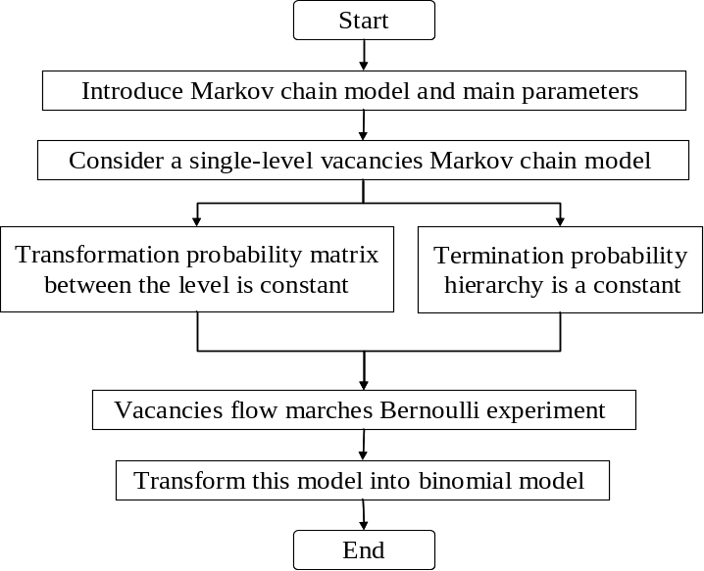
Figure 1 Analysis diagram of problem one

4.1.2 Solution of the problem
(1) Model preparation
①Overview of the Markov chain model
Markov chain is a discrete time stochastic process with Markov mathematical nature. This process, in the case of given current knowledge or information, the past is irrelevant to the prediction for the future.
Markov process which time and states are discrete is called Markov chain, abbreviated as:
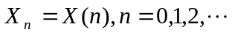
Markov chain is a sequence of random variables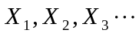. The scope of these variables, i.e., the set of all possible values ​​of them, called "state space". The value of 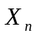 is a state in the time. If the conditional probability distribution over the state of 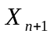 is only a function of, then
Here is a state in the process.
②Nature of the Markov chain model
Markov chain is represented by the distribution of this condition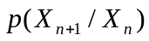, this is called as "transition probability" of a random process. This is sometimes referred to as "one-step transition probabilities". Two, three, and more steps transition probabilities can be guided from one-step transition probability and Markov property:
③The main parameters of the Markov chain model
A Markov chain model can be expressed as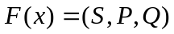.The meaning of each element: is a non-empty set of all possible states of the system, sometimes called the state space. 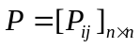 is the state transition probability matrix of system. 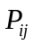 represents the probability of the system in the state at time ,  is the number of all possible states of the system. For any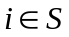, there is: 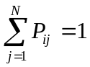; 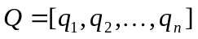 is the initial probability distribution of the system, 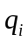 is the probability of the system in the state at the initial time. It meets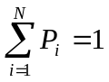.
(2) The establishment of the model
Vacancy chain is a flowing sequence triggered by a vacancy.
Parameter: The length of the chain, namely flowing times the number of job vacancies of the system;
Parameter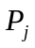: It represents the probability of binomial model, and the length of the vacancy chain is;
Parameter: The average length of vacancy chains;
Parameter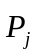: It is a column vector formed by the polymerization of these probabilities corresponding to each;
Parameter: It is a Unit matrix that has the same column with.
At this point  is reduced to the number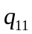, the vector  is simplified to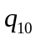. Thus, the former is relabeled as, the latter is relabeled as.
At this point: 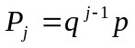, Parameter is a positive integer. (1)
The average length: 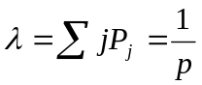. (2)
Assuming that each level that vacancies can enter corresponds to a particular probability distribution. At this time, the product of i row of the matrix 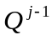 and column vector 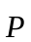 is the probability of vacancy chain that starts at the i level and just terminates at the j layer.
Namely: 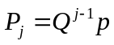. (3)
Each distribution now can be normalized as: 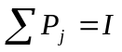. (4)
According to the level that vacancies enter in, put the average length into vector.
Then: 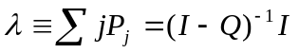. (5)
At this point in the matrix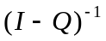, the i row and the k column element is an expected number, the expected number is the times that a vacancy which has already entered i layer will occur in the k layer.

4.1.3 Application examples of model (Apartment resource optimization)
① Case Study
Similar to "hermit crabs find a new shell", once new apartments appear in the real estate market, Markov effect of vacancy chain will occur. Once there is a tenant moving to the new apartment, in principle, there will be the second tenant; the third, the fourth and so on.
When the last tenant moves into the new apartment of single-level, this single-level vacancy chain Markov effect ends. Vacancy chain relationships of the apartment move as Figure 2 shows.
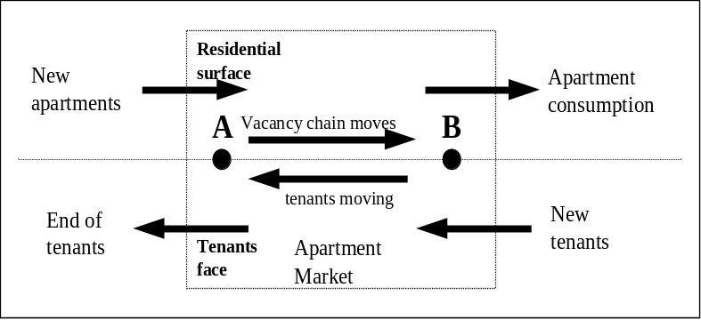
Figure 2 Apartment vacancy chain relationships moving diagram
② Conclusion
Combining with the specific circumstance of the apartment problem, we can apply the single-level vacancy chain Markov model to this instance. Use the model of this problem to give a few explanations:
Firstly, you can start the study for the flow of apartments with the houses or the moving households. But anyway, the transfer of the tenants and of the apartments is presented as dual relation.
Secondly, from the point of single-level vacancy chain, every vacant apartment is an opportunity for every household, it was only because of the households’ own abilities that they can not choose a specific apartment, so the longer the apartment remains empty, namely the longer the vacancy chain is, the greater chance for apartments households will have.
Then, essentially, the flow of apartments can be considered to improve the quality of life of the households. But it must guarantee that apartments with high quality will join in the operation of the apartment market in the process.
Finally, it can be seen that the whole process of the apartment chain flow not only improves the quality of life for all households, but also has a positive role in the government old house renovation and GDP promotion.

4.2 Model two: Multi-level vacancy chain Markov model

4.2.1 Analysis of the problem
Problem two requires to establish a multi-level vacancy chain Markov model, and to give an example of the application. In problem one, we have explored the single-level vacancy chain Markov model, but this is a special situation, not fully adapt to the real world with multi-level vacancy chain. Therefore, we consider the situation of multi-level vacancy chain on the basis of model one, and establish a multi-level vacancy chain Markov model to expand the adaptability of the model in real life. (As shown in figure 3)
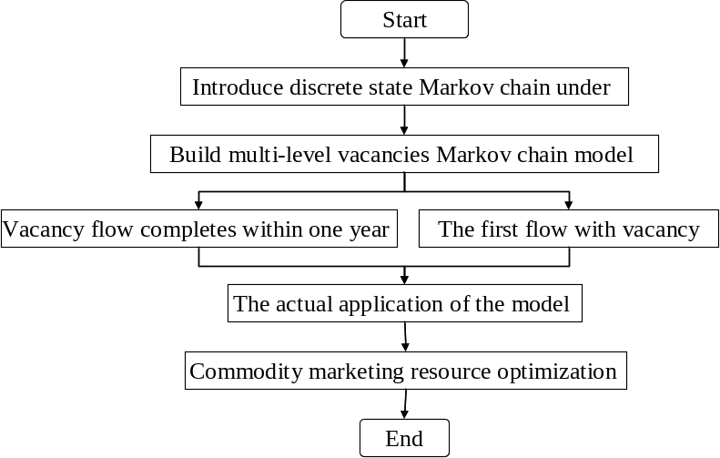
Figure 3 Analysis diagram of problem two

4.2.2 Solution of the problem
(1) Model preparation
To give the better derivation of multi-level vacancy chain Markov model, we Profile the Markov chain model in discrete state space.
When the state space is limited, use "transfer matrix" with elements 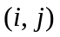 to represent the transition probability distribution:
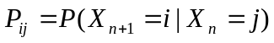
For a discrete state space, the integral of k steps transition probabilities is the summation. We can raise the transfer matrix to the k power to get it. That is, if  is a one-step transition matrix, 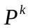 is the "transition matrix" after k steps transfer.
The stationary distribution vector satisfies the equation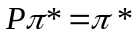.
In this case, the stationary distribution 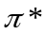 is an eigenvector and the characteristic value is 1 and ​​ is the transfer matrix.
If the transfer matrix can not be simplified and is non-periodic, then converges to a stationary distribution that each column is different. And there is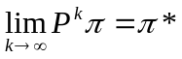, it is independent of the initial distribution.
Positive transition matrix is irreducible and non-periodic. Matrix is called a random matrix only if it is a transition probability matrix in a Markov chain.
NOTE: In the above formula, element is the probability that transfer to . In this case, the transfer matrix is only the transpose of the transition matrix given here. In addition, the stationary distribution of a system is determined by the left eigenvector of the transition matrix given instead of right eigenvectors.
(2) The establishment of the model
In a multi-level vacancies Markov chain model, different with the order of continuous flow in the chain, we can not specify the exact time, but only use the conditional probability. Stipulate that a range of flow sequence occurs between two consecutive years is a complete vacancy chain. To simplify the model calculation, it is assumed: the vacancies that get into the system are taken as consecutive year cohorts, each cohort has left the system before entering the next cohort.
Parameter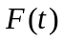: the number of vacancies during the t year in cohort;
Parameter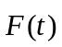: Represents row vectors of vacancies at all levels.
Parameter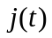: The average total length of the vacancy chains in one class;
Parameter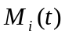: Represents the forecast for total number of each class, 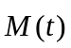on behalf of the arrangement of all levels, 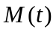on behalf of the predicted total;
Let x represent the proportion of vacancies in the different levels, there are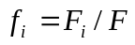. Ensure the transition probabilities within the range of all flow intervals of the vacancy chain remain constant within a year. In this case, if make use of a suitable level, these parameters should remain unchanged for a long time, so there is no time dependency.
So, we can establish a multi-level vacancy chain Markov model.
By the equation (3) of the model, we have a distribution of total length of a cohort vacancy chain: 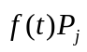. In the case, the average total length of vacancy chains is expressed as:
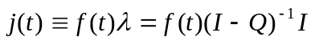 (6)
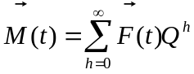 (7)
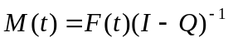 (8)
(9)
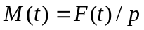 (10)
In the multi-level vacancy chain Markov model, all flows have occurred within one year, namely the maximum length of a single chain can only be one year. Each vacancy has to be carried out first flow to ensure that the second level is closely related to the first level.

4.2.3 Application examples of model (Supermarket marketing process optimization)
① Background
ⅰ.Introduction to the marketing process
To reflect the role of multi-level vacancy chain Markov model in marketing optimization process better, we need to understand the key processes of marketing firstly. Marketing process can be divided into the main process of identifying, contacting, transactions and maintenance. Drawing shows four main stages of marketing, you can see the figure 4.
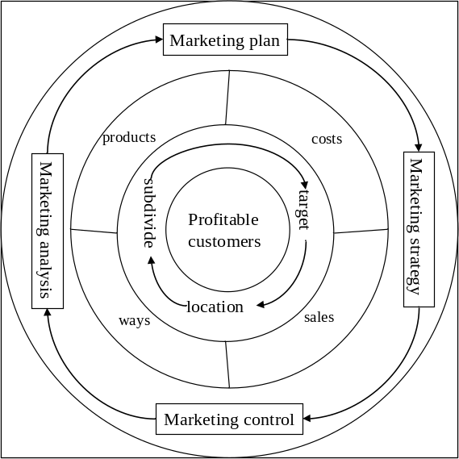
Figure 4 Main stages of marketing
The ultimate goal of marketing is to maximize have a stable consumer groups and lucrative income as much as possible. First, companies positioning for the market segments through the selection of the target market, and design products and services provided by the enterprise to meet the needs of customers further. Secondly, design effective implementation of the marketing mix, including price, place, promotion and other aspects of the product. And then control the marketing plan in different aspects.
ⅱ. The feasibility of this model be applied to the marketing process optimization
Firstly, there is a variety of commodities with different prices, uses in the supermarket. They correspond to different levels of a multi-level vacancy chain.
Secondly, the supermarket area and the maximum number of placed items are fixed. To guarantee that popular products be placed on the prominent position supermarket can make the supermarkets sell maximum goods. In addition, selecting a strong correlation of different merchandise mix will attract potential consumers. This phenomenon is similar to the situation that a high level vacancy in the vacancy chain corresponds to the individual with maximum value.
Finally, the use of multi-level vacancy chain Markov model can make different individuals of all levels to get the optimal allocation, which is the same with the goal of the supermarket, the goal is to sell maximum goods to get maximize profit.
In summary, we say that applying the multi-level vacancy chain Markov model to the marketing process optimization is feasible.
② Specific application
Based on supermarket space constraints, selling the commodities with strong correlation together will greatly increase the probability of potential revenue. So, use the model and the relevant formula to calculate the optimal configuration.
Some commodities imply correlations. After consumers buy some product, what happen next depends largely on previously purchased products. The key is to calculate the probability of purchase and time interval between purchasing two goods.
Set up any two states of a multi-level vacancy chain Markov model as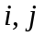.
define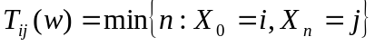，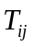 is called the time that the first moment arriving from to .
Call 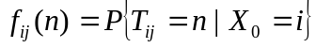 as the probability of the first moment arriving from to.
. Denoted as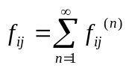;
According to the vacancy chain Markov model created previously, we know：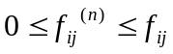.
When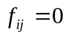, it means that the state can not reach the state.
When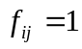, it means that the state must reach the state.
Define, 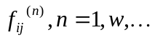is a distribution law. So, 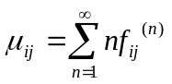.
It represents the average time that start from towithin a finite number of steps. Especially when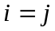, it represents the period of the return to the state from the state . After calculating, making the correlation of the products more concentrated.
As for practical application, we just need one supermarket’s all kinds of commodities’ month sales, and put them into the expression of model to get the results.
③ Conclusion
ⅰ. Achieve a bundling of different goods with strong correlation
Firstly, use the data to study the consumer products association preliminarily and to analyze a reasonable choice of product combinations. So the marketing focus turned to those products with high transition probability and short cycles. And make them combined to sell.
Secondly, combine the multi-level vacancy chain Markov model with association rules. Based on the size of transition probability value of all levels of vacancy chains’ state, we improve products’ correlation and narrow the scope of the relevant product progressively by cyclical iterative calculations of. This can realize product bundling.
Obviously, in order to achieve the purpose of increasing the potential consumption, we can put the relevant products together to sell.
ⅱ. Choose the best place to put the goods
Based on examples of data of Supermarket sales, the implicit association of some products and changes in the number of customer groups can be drawn by the application of the multi-level vacancy chain Markov model. By the valid use of the results, we can provide complementary support to the supermarket marketing decisions. When we learned that the number of customers at different levels, we can choose analysis object according to our own needs, bundling products or making optimization choices when placing goods.
In summary, the multi-level vacancy chain Markov model can realize the optimization of product marketing resources, making the owner to obtain higher profits.

4.3 Analysis and solution of problem three

4.3.1 Analysis of the problem
Obviously, this problem is an exploration for the application scope of model one and two. We can see it’s unrealistic for a model to be applied to various industries. Therefore, the study focuses on working out how to set appropriate conditions for making the model be applied as widely as possible. We use block diagram form to show the basic ideas of this problem.
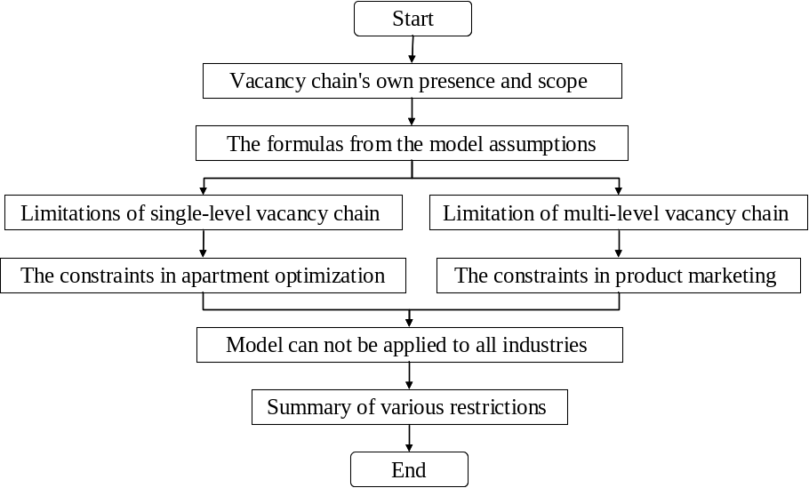
Figure 5 Analysis diagram of problem three

4.3.2 Conditions for the model to meet
(1) Presence conditions and scope of application for Vacancy chain
Vacancy chain is a time series generated by the vacancy. The existence of a vacancy chain requires certain conditions.
① Vacancies arise. That "hermit crab" finds, a very beautiful but not suitable shell is a vacancy, it represents that something new with a higher quality appears in a level.
② Each individual in the system meets the expectations of their higher satisfaction by vacancy chain flow.
③ Each individual must make a choice in a short time, and you can only make one choice.
④ Vacancy chain flow has a time limit, not always happen.
(2) Conditions of single-level vacancy chain Markov model
If the vacancy chains exist, in the case of the following conditions are satisfied, the single-level vacancy chain model is meaningful.
① Each post can have only one incumbent, and one can only occupy one position. The system we study is composed by the positions and incumbents.
② A large system composed of different positions requires that all positions gather together at the same time. Considering that the nature of jobs are the same, but there is a slight gap in salary conditions.
③ The maximum length of the vacancy chain is one year, that is, the flow processes of one level are all within a year.
④ Assume that all vacancies flow in the systems is independent, and they all follow the same probability model.
(3) Constraints in apartment resource optimization
When the single-level vacancy chain Markov model meets the certain conditions, we also need the following limitations before applying it to the optimization for apartment resources.
① Identification for idle apartments. The apartments that are available for leasing or selling in short time can be identified as idle apartments. Owners take them for investment, appreciation or store for use by themselves or their children can not be considered into the model.
② Transition matrix has the same attributes. Need to meet stability for all levels of markets and also need to ensure that the transition probability of the transition matrix remains unchanged within two years.
③ Each household has the expectation to improve housing conditions. That is, if they have the abilities, they will sell their former apartments to buy high-quality new apartments when high-quality new apartments appear.
(4) Assumptions for multi-level vacancy chain Markov model
Multi-level vacancy chain Markov model is an extension of single-level vacancy chain Markov model, which in addition to meet the establishment conditions (2), the following conditions must also be required:
① Continuity. There must be a vacancy having first flow, first grade must be the initial level of second grade.
② Vacancies retention time is limited. It means that a person who leaves the job but not gets another job soon, he/she is identified as leaving the system. It creates a vacancy.
③ Transition probabilities of domestic should remain unchanged in one year. If levels have been divided, these parameters can not be changed in a very long time.
(5) Commodity marketing restrictions
In order to make the multi-level vacancy chain Markov model be applied to the supermarket merchandising optimization process, customer behavior has the following limitations:
① There is no one-time buying behavior.
② Don’t consider the impact of the decision-making time. That is, when customers think about buying what kind of goods, the length of thinking time will not affect their purchase of other goods.
③ Do not consider the customer's age, identity and gender.
④ Exclude the impact of time and the season.

4.3.3 Conclusion of the problem
Earlier we discussed the restrictions of the establishment that the model demands, which means that the vacancy chain model is unrealistic for optimization for all industries.
A model is an abstraction of a realistic problem. The model can be established only under certain assumptions. The models we established before demand many specific assumptions. So we can say that there is no vacancy chain optimization model that can be applied to various industries.
① Have a vacancy for the first time the flow.
② Each individual in the system has a desire to get greater satisfaction through vacancy chain flow.
③ Probability distribution of the system state at time 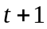 only has connection with the state of the time .
④ Each vacancy in the system flows independently, and they follow a specific probability distribution.
These four rules are the most basic conditions that vacancy chain Markov model is applied to all industries, and they must be followed.

4.4 Model three: Vacancy chain prediction model

4.4.1 Analysis of the problem
According to the Integrated model has been built above and the specific requirements in this question, we build the vacancy chain model to predict the change of HR expends for some enterprise customers within the next five years. We show the idea of building model as figure 6.
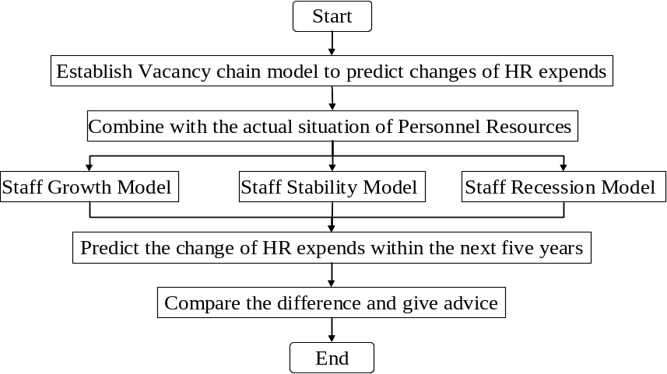
Figure 6 Idea of vacancy chain prediction model
In this model, we use the past personnel changes to speculate the future trend of the personnel changes. According to the type of customers that Human Resources website may encounter, we divide them into three models, growth, stability and decline. We respectively estimated personnel changes and the total cost of human resources in three models within the next five years, and analyze the effects of three models in both employees and employers.

4.4.2 Solution of the problem
(1) Model preparation
We establish a staff vacancy model for constructing following vacancy chain forecast preparation at first.
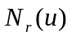—The observed numbers of personnel in the layer from 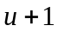 to;
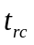—All staffs flow fromlayer tolayer in this year;
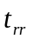—The number of retaining staffs inlayer;
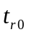—The number of leaving staffs in layer;
—The number of all layers.
Considering applicants will also affect the predicted numbers of flow from one level to another level, we let 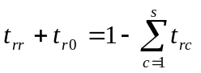.
Let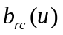as predicted number of flow from one level to another level in 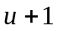year. We get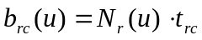.
(2) The establishment of the model
—Vacate the transfer rate of the transfer matrix (Figure out transfer rate based on the historical datum);
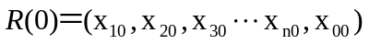—Statistical distribution of the initial year of all departments of personnel;
We establish the vacancy chain prediction model to predict the future supplement of all departments of personnel. The vacancy chain prediction model based equation is as follow:
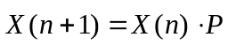
In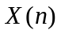, 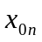 represents the number of leaving job staffs in the year. 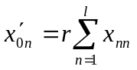is the number of applicants on the condition of the growth rate at in ever year.
In the equation, represents trend analysis and forecasting object state vector in the moment from to; represents transition probability matrix; 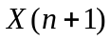 represents trend analysis and forecasting object state vector in 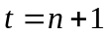 moment.
Assuming all departments transferred staffs training costs is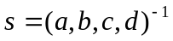. Figuring out the HR expends is 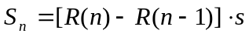 in every year.
Figuring out HR expends in the company, we let the revenue in every departments is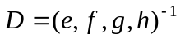. Than we get the HR expends in every year is
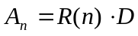；
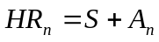。

Staff growth model
According to the statistical results of questionnaire survey in the company, we found the number of high-level decision makers, middle managers, technical personnel (investment promotion personnel, finance, law enforcement personnel, planning and construction personnel) as follows. There are 7 high-level decision makers, 32 Management personnel and 133 Technical personnel. There are 172 persons in total. So the proportion of the total staff of three departments is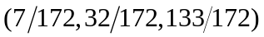.
Now create a vacancy chain model, based on the statistical survey of number of various types of staffs in the company shows that the number of initial vectors of high-level decision makers, middle managers, technical personnel is 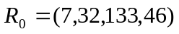.Assuming the annual flow of company's three departments is that 8O% senior decision-makers have left, leaving the rest; management personnel have 6O% left, 5O% senior decision-makers, leaving 35} 7O% technical personnel have left, 2O% management personnel, 10% of employment. The transferred costs in every department are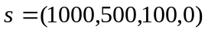. The total applicants’ number into three departments of the company is increase at 25.98% every year. Two high-level decision makers, nine management personnel and thirty-five technical personnel shall be supplemented in average annual, and the average total number of people supplement is 46 in 2013 and 2014. We get the transfer matrix as follow.
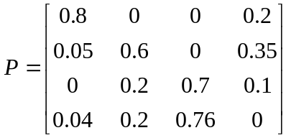
The rate of annual personnel supplement is show in the last line in the transfer matrix. It is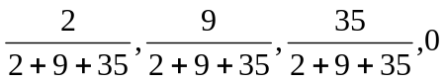.
The first transfer (the training costs and the number of personnel in 2014)
R(1)= R(0)·P= (7,32,133,46)·P= (9,55,128,26);
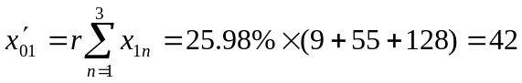
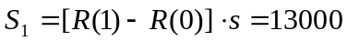;
The second transfer (the training costs and the number of personnel in 2015)
R(2)= R(1)·P= (9,55,128,42)·P (12,67,122,34);
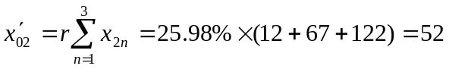
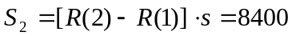;
The third transfer (the training costs and the number of personnel in 2016)
R(3)=R(2)·P=(12,67,122,52)·P= (15,75,125,38);
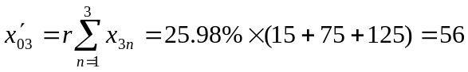
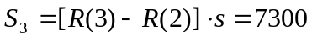;
The forth transfer (the training costs and the number of personnel in 2017)
R(4)=R(3)·P=(15,75,125,56)·P= (18,81,130, 42);
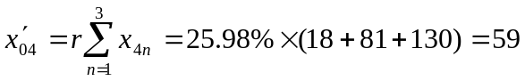;
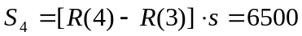;
The fifth transfer (the training costs and the number of personnel in 2018)
R(5)=R(4)·P=(18,81,130,59)·P= (21,86,136,45);
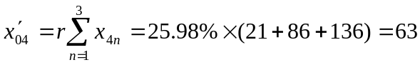;
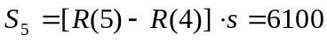.
We select the change of personnel numbers in every department and show as figure 7.
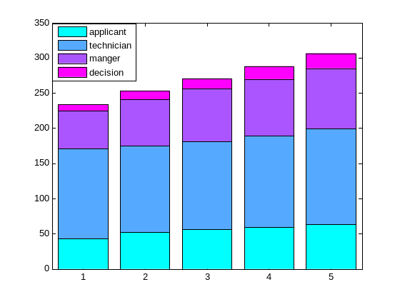
Figure 7 The change of personnel numbers in every department from 2014 to 2018
The first transfer (HR expends in 2014):
The second transfer (HR expends in 2015):
The third transfer (HR expends in 2016):
The forth transfer (HR expends in 2017):
The fifth transfer (HR expends in 2018):
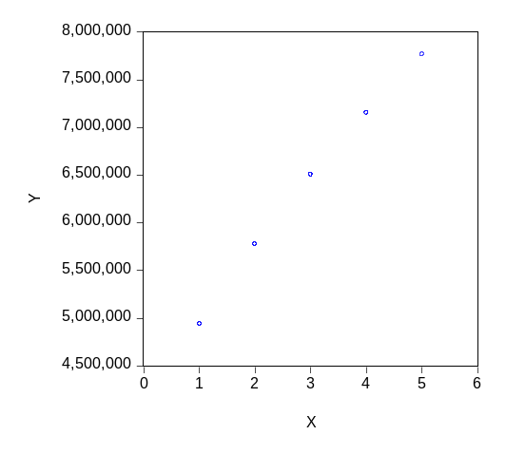
Figure 8 The change of HR expends from 2013 to 2018
The company is a typical staff growth model. It can be seen from the figure 8 that the number of staffs in this company is an upward trend, which the increasing in the technician department is not very obvious, and the manger and decision departments increase more than it. As applicants started working from the basal level in the company and the internal liquidity among the company is relatively large, the manger and decision departments are more. For employees, they have a greater expectation of promotion. But for employers, it will have some influence that the promotion of staffs adapt to the new working environment and train for the new position.

Staff stability model
Based on staff growth model, we change the condition "The total applicants number into three departments of the company is increase at 25.98% every year," to "Total staffs don’t change in every year.”. Similarly, we can get the number of annual recruitment and human resources costs.
Table 1 The annual number of every department in staff stabilized company
year | decision maker | manager | technician | applicant
2014 | 9 | 55 | 128 | 26
2015 | 11 | 64 | 109 | 34
2016 | 13 | 67 | 102 | 35
2017 | 15 | 68 | 98 | 36
2018 | 17 | 68 | 96 | 37
We show the table 1 as follow figure 9.
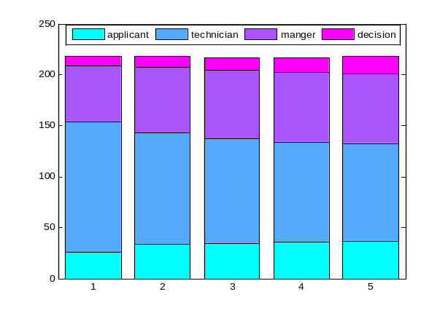
Figure 9 The change of the number of staffs in stabilized company from 2014 to 2018
As the staff growth model, we figure out the HR expends from 2014 to 2018. We show it as Table 2 .
Table 2 stabilized company’s HR expends in the following years
year | 2014 | 2015 | 2016 | 2017 | 2018
HR expends | 4943000 | 5394600 | 5672800 | 5882100 | 6061800
It is a staff stability model. We can know that the company has little change in personnel from the figure 9. But in fact, it has some reductions in the number of technician lever, a small part of increases in manger layers and relatively flat in applicant layer. Although the cost of training and mobility of HR will lead to increase costs in stabilized company, but the rate of increase isn’t faster than the growth model. For employees ,who is in the technician layer will have more chance to promote than other department, but for employers, it have less influence on the company that technicians promote to mangers .

Staff recession model
Based on staff growth model, we change the condition "The total applicant number in three departments of the company is increase at 25.98% every year," to " The total applicants number into three departments the company is decrease at 25.98% every year,”. Similarly, we can get the number of annual recruitment and human resources costs.
Table 3 The annual number of every department in staff recessionary company
Year | decision maker | manager | technician | applicant
2014 | 9 | 55 | 128 | 41
2015 | 12 | 68 | 121 | 35
2016 | 14 | 72 | 111 | 29
2017 | 16 | 71 | 100 | 24
2018 | 17 | 67 | 88 | 19
We show the table 3 as follow figure 10.
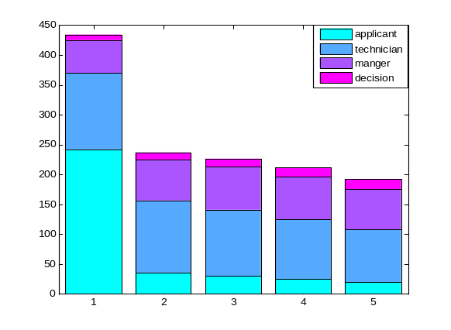
Figure 10 The change of the number of staffs in recessionary company from 2014 to 2018
Note: Fixed the number of recruits in 2013 year leads to the gap between the 2015 staff to 2016.
Figure 10 shows the change of the number of staffs in recessionary company in the following years. As the staff growth model, we figure out the HR expends from 2014 to 2018. We show it as Table 4.

Table 4 recessionary company’s HR expends in the following years
year | 2014 | 2015 | 2016 | 2017 | 2018
HR expends | 4943000 | 5818800 | 6113000 | 6150400 | 5927800
It is a staff secession model. We can know that the company has declined in personnel. Specifically, it has some reductions in the number of applicant department, relative reduction in technician departments and relatively flat in manger and decision departments. From the figure 10, we also can know that applicant and technician departments reduce more sensitive than the other two departments. For employees in the technician department will have more dangerous to lost job than other departments. But for employers, HR expends and company's output will significantly reduce, if only reduce the number of upper departments.
From the Model three, we can know the three different types’ advantages and disadvantages in both employees and employers. We advice the web have a survey to some typical companies to know the employees and employers’ demands. Combining the condition of the model analyzes each type of companies’ applicants the most appropriate number. We make model three result as an example and show as follow:
We design the web head as figure 11. The content can include Home, Service, Rate and Client est. It will help web surfers to find what they want quicker.
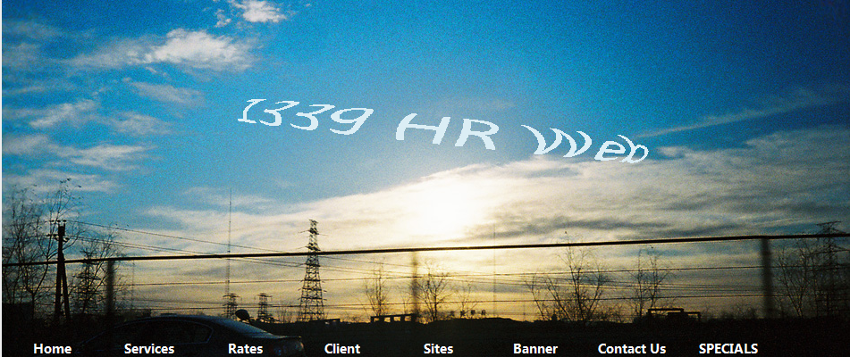
Figure 11 Part one of the web
We design the web main head as figure 12. It introduces the basis condition of the example company and the idea of the whole article.
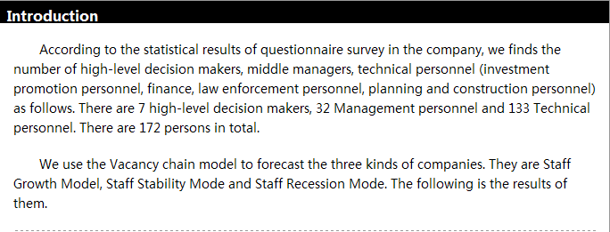
Figure 12 Part two of the web
We design the web main head as figure 13. We show the assumptions of different companies in this part to make the web more methodical.
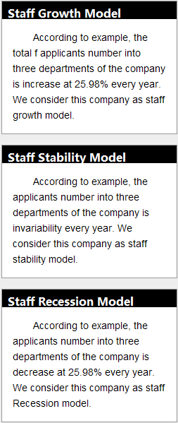
Figure 13 Part three of the web
We design the web main parts as figure 14. We show the Staff Grow Model main features in personnel distribution and HR expends in the following every year. Considering both employees and employers, we give some advice in next five years.
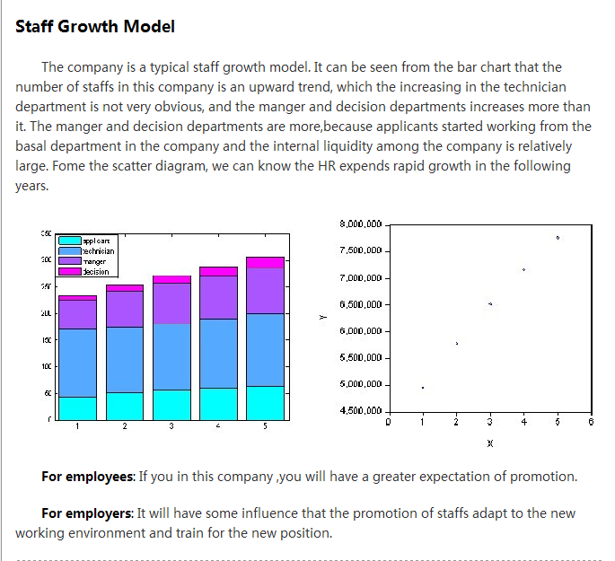
Figure 14 Part four of the web
We design the web main parts as figure 15. We show the Staff Stability Model main features in personnel distribution and HR expends in the following every year. Considering both employees and employers, we give some advice in next five years.
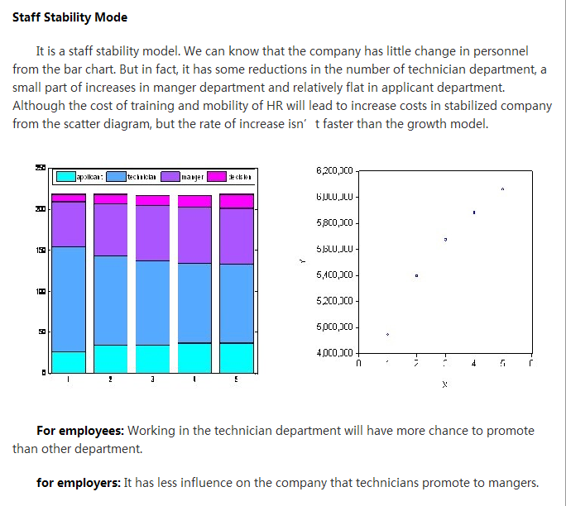
Figure 15 Part five of the web
We design the web main parts as figure 16. We show the Staff Recession Model main features in personnel distribution and HR expends in the following every year. Considering both employees and employers, we give some advice in next five years.
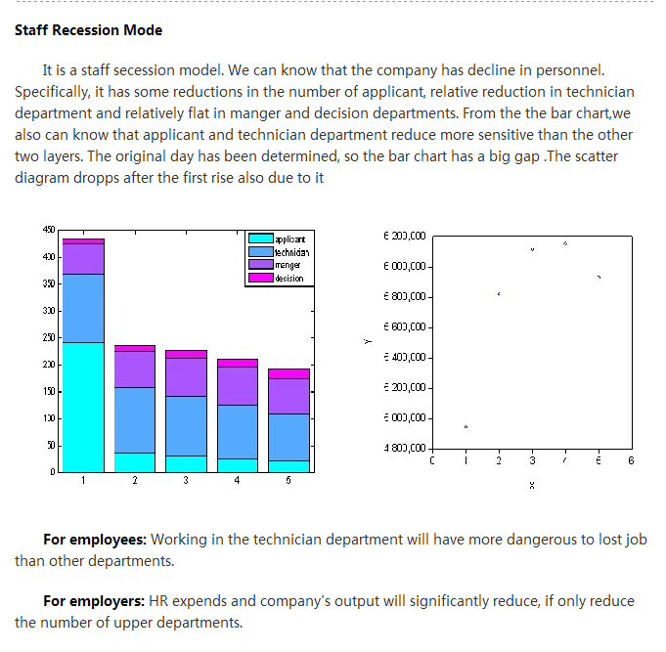
Figure 16 Part six of the web

Complete Webpage:
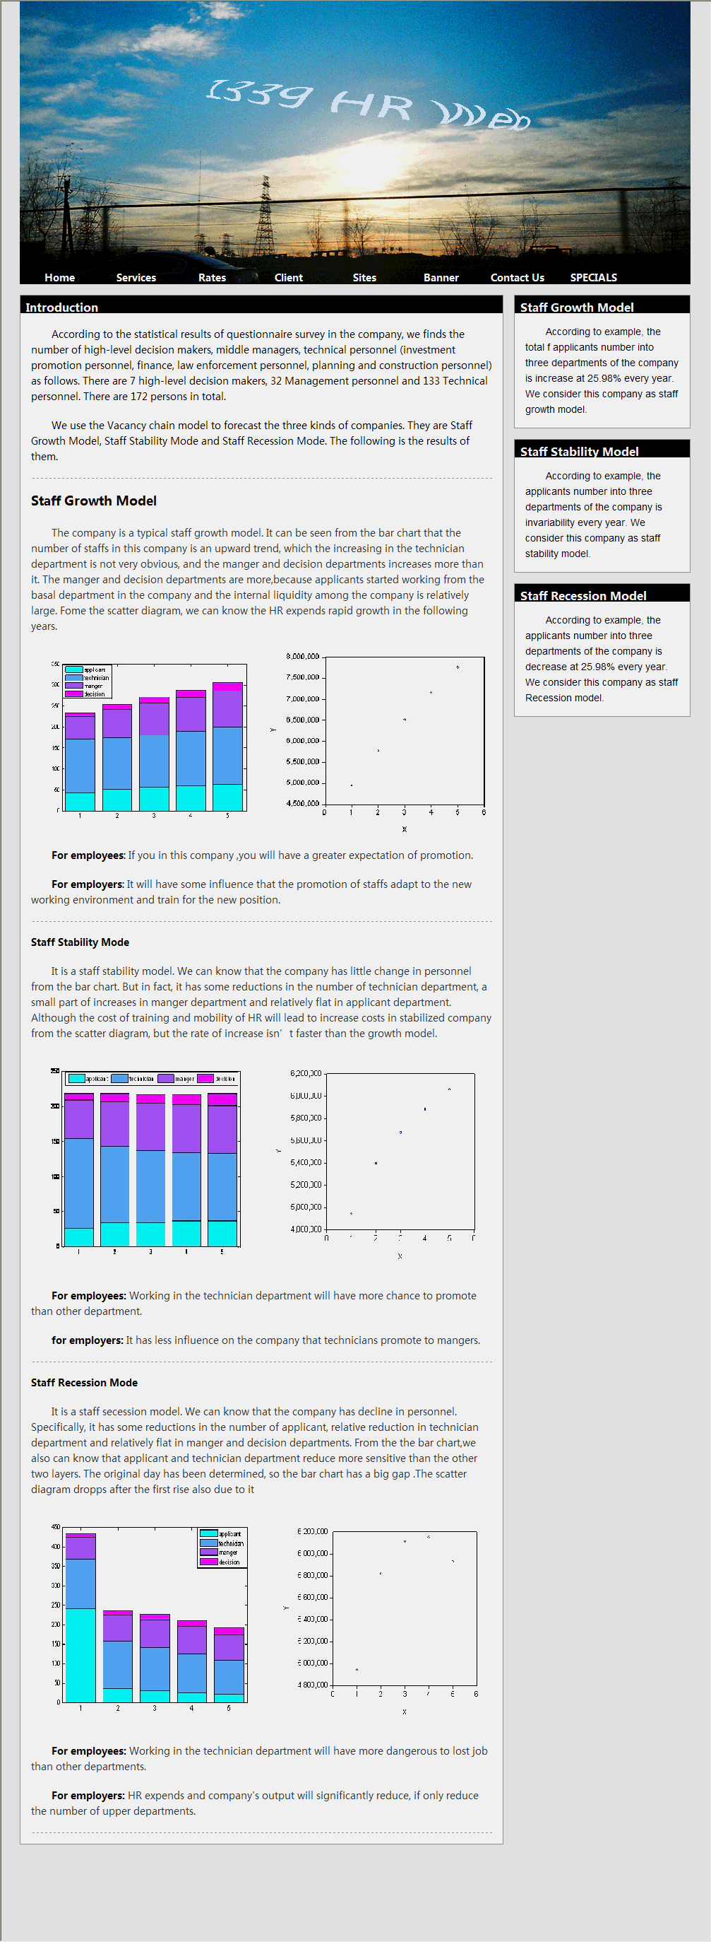

5 Improvement for model

5.1 The need of improvement for model
When using the model three to solve the problem four, we make some assumptions: the annual ratio of staff flow from a given level to the other levels is constant in a short time during the five years. This is possible in the research of problem four, because of the time span is only five years. But if a company now calls a study for human resources within ten or twenty years, forecasting results of the model three may be not very accurate.
On this basis, we have improved the model three so that it can play a role in human resources forecasting.

5.2 Predictive models of long time human resources costs
For each individual, it must choose the level and must estimate transition probabilities. They need to record changes of vacancies in each period, and take them as the initial conditions.
Define the following parameters:
Parameter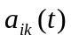: The total of a sample extracted from the vacancy group that flow from the i layer to the k layer.
Parameter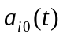: The number of the termination of flow.
Parameter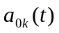: The number of vacancies in the k layer that can be observed in the sample x layer.
Parameter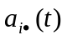: The sum of the flow from the i layer, including terminal flow.
Parameter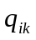: Transition probabilities for each level.
We use the portion of the flow from the i layer to the k layer 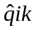to estimate the transition probability. 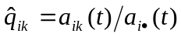.
At this point, the distribution of vacancies at all levels in the year can be estimated as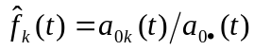. 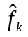: An estimate of the sample.
Summation：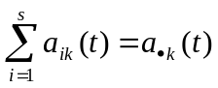  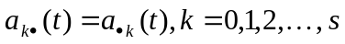
The selection of the dependent variable to be predicted is very important. Assumptions of all levels of the model can not be verified alone, so that the model should be considered as a whole.

5.3 Advantages
Compared to the model three, this model is a more flexible predictive model, which has a great advantage in terms of the prediction for changes in the cost of human resources with a long time. Several advantages are given below:
① You can enlarge the number of vacancies arising in different years. The model is not only dependent on the number of observations for a given year, in fact, considering the vacancy chains flow throughout the system;
② In this model, the flow is the result of vacancies. Compared to model three, we not only take the number of staff that converted from low-level to senior-level into consideration, the main consideration is the change process of vacancies.
③ Relative to the model three, the model can not only be suitable for individual jobs, but if you assume that people can only fill vacancies by flow, new positions and dead positions can be treated equally. The model records new recruits and dead officers to have a duality between staff and positions.

6 Evaluation for model

6.1 Advantages
1. Use flow charts to show the complex thought of modeling intuitively.
2. Based on Markov prediction model, we established the vacancy chain model. Do not just predict the number of transfers of each level, but consider the flow of vacancies chain as much as possible.
3. After each model, the application examples are given. The abstract mathematical expressions are used in practice, and readers will understand the nature of the model easier.
4. We recognize that our models’ applicable range is limited. To ensure the rigor of the paper, in the problem three, we analyze the applicable conditions of both the model one and two and their application examples. In the end, we give some certain assumptions.
5. Given that the model three can not predict the cost of long time human resources well, we build a predictive model for the cost of long time human resources to compensate for this defect.
6. Finally, we created a simulate human resources website specially, only to highlight the policies and views on changes of human resources expends better.

6.2 Disadvantages
1. The practical application of the model requires a lot of data to support, but time does not allow us to go out to collect data, so in the example analysis of model one and two, we do not give a lot of specific numerical results, which is regrettable. But we give the specific application procedures and methods, so the impact is not great.
2. Due to the broad aspects of this question, it is not very exhaustive in the modeling process. But we have tried to discuss the involved aspects more fully.

References
[1] Kyomin Jung, Shah, D. Distributed averaging via lifted Markov chains[C]. IEEE Transaction on Information Theory .2010, 56(1):634-647.
[2] F Gao, J Sun, Z Wei. The prediction role of hidden Markov model in intrusion detection Electrical and Computer Engineering, 2003, 2: 893-896
[3] Pfeifer P, Caraway R. Modeling customer relationships as Markov chains [J].Journal of Interactive Marketing, 2000, 14(2):43-55.
[4] W-K Ching ,ES Fung, MK Ng, A higher-order Markov model for the Newsboy’s problem[J]. Journal of the Operational Research Society, 2004, 55:860-868.
[5] Yariv Ephraim，William J.J. Roberts. An EM algorithm for Markov modulated Markov processes[C].IEEE Transactions on Signal Processing, 2009, 57(2):291-298.
[6] Nicol D M, Sanders W H, and Trivedi K S. Model based evaluation: From dependability to security. IEEE Transactions on Dependability and Security, 2004, 1(1):48-65
[7] RC Blat berg ,Getz, JS Thomas．Customer Equity：Building and Managing Relationships as Valuable Assets[J].Boston：Harvard Business School Press .2001.
[8] Bergson, Smiths. Building data mining applications for CRM . New York. Mc Graw Hill，1999,139-144.
[9] Jiang，L．S．．Mathematical Modeling and Methods of Option Pri—cing[M]．Singapore：World Scientific Publishing Company，2005
[10] Lawrence T. Pinfield. Vacancy Chains as Bundles of Staffing Actions[M]. US: Springer US 1995, pp 61-7

Appendix
<!DOCTYPE html PUBLIC "-//W3C//DTD XHTML 1.0 Transitional//EN" "http://www.w3.org/TR/xhtml1/DTD/xhtml1-transitional.dtd">
<html xmlns="http://www.w3.org/1999/xhtml">
<head>
<meta http-equiv="Content-Type" content="text/html; charset=gb2312" />
<title>HR </title>
<style type="text/css">
body{
margin:0;
background:#eee;
}
#wrap,#header,#content,#footer{
width:950px;
margin:0 auto;
}
#header{
height:400px;
background:url(../../blog/header.jpg) no-repeat;
margin-bottom:15px;
position:relative;
}
#main{
width:683px;
background:#FFFFFF;
float:left;
border:#999999 1px solid;
}
#sidebar{
width:250px;
float:right;
}
#footer{
height:80px;
margin-top:15px;
}
#header h1{
color:#333;
position:absolute;
top:32px;
left:205px;
width: 612px;
height: 276px;
}
#header span{
font-size:2em;
font-weight:normal;
font-family: Microsoft Accor black;
}
#header ul{
list-style-type:none;
margin:0;
position:absolute;
right:6px;
bottom:-1px;
width: 941px;
height: 29px;
}
#header li{
float:left;
}
#header a{
display:block;
width:108px;
height:38px;
line-height:38px;
color:#fff;
font-size:14px;
font-family: Microsoft Accor black;
font-weight:bold;
text-decoration:none;
text-align:center;
}
#header a:hover{
color:#FFFFFF;
text-decoration:underline;
}
.title{
height:25px;
background:#000;
color:#FFFFFF;
font-size:0.8em;
font-weight:bold;
padding-left:0.5em;
line-height:25px;
}
.sidebox{
width:248px;
background:#FFFFFF;
border:#999999 1px solid;
margin-bottom:15px;
}
.mainbox{
margin:15px;
border-bottom:#999999 1px dashed;
}
.mainbox .right{
float:right;
}
.mainbox p{
font-size:0.9em;
line-height:1.5em;
color:#333333;
text-indent:2em;
}
.mainbox1 {
margin:15px;
border-bottom:#999999 1px dashed;
}
.mainbox1 .right{
float:right;
}
.mainbox1 p{
font-size:0.9em;
line-height:1.5em;
color:#000000;
text-indent:2em;
}
.mainbox1 h3{
font-size:1em;
}
.sidebox p {
margin:15px;
font-size:0.9em;
line-height:1.5em;
color:#000000;
text-indent:2em;
}
#footer p{
font-size:0.8em;
line-height:1.5em;
color:#999999;
text-align:center;
}
.clear{
clear:both;
}
.STYLE1 {
font-size: xx-large;
color: #CC0000;
}
.STYLE2 {
font-size: 0.9em;
font-family: " Microsoft Accor black "}
.STYLE8 {height: 25px; background: #000; color: #FFFFFF; font-size: 1em; font-weight: bold; padding-left: 0.5em; line-height: 35px; font-family: " Microsoft Accor black "; }
.STYLE10 {font-size: 0.4px; font-family: " Microsoft Accor black ";}
.STYLE16 {
font-size: 1em;
font-family: " Microsoft Accor black ";
}
.STYLE18 {font-weight: bold; font-family: " Microsoft Accor black ";}
.STYLE20 {font-size: 1em; font-weight: bold; color: #000000; }
.STYLE21 {color: #000000; font-size: 1em; }
.STYLE24 {color: #000000; font-weight: bold; }
.STYLE25 {font-size: 0.9em; font-family: Geneva, Arial, Helvetica, sans-serif; }
.STYLE29 {font-size: 2em}
</style>
</head>

<body>
<div id="wrap">
<div id="header">
<h1><img src="top.gif" width="611" height="275"/></h1>
<ul>
<li><a href="#" class="STYLE1">Home</a></li>
<li><a class="current" href="#">Services</a></li>
<li><a href="#">Rates</a></li>
<li><a href="#">Client</a></li>
<li><a href="#">Sites</a></li>
<li><a href="#">Banner</a></li>
<li><a href="#">Contact Us</a></li>
<li><a href="#">SPECIALS</a></li>
</ul>
</div>
<div id="content">
<div id="main">
<div class="STYLE8"> Introduction </div>
<div class="mainbox1">
<p class="STYLE10">According to the statistical results of questionnaire survey in the company, we finds the number of high-level decision makers, middle managers, technical personnel (investment promotion personnel, finance, law enforcement personnel, planning and construction personnel) as follows. There are 7 high-level decision makers, 32 Management personnel and 133 Technical personnel. There are 172 persons in total.</p>
<p class="STYLE10">We use the Vacancy chain model to forecast the three kinds of companies. They are Staff Growth Model, Staff Stability Mode and Staff Recession Mode. The following is the results of them. </p>
</div>
<div class="mainbox">
<h3 class="STYLE18">Staff Growth Model</h3>
<p class="STYLE16">The company is a typical staff growth model. It can be seen from the bar chart that the number of staffs in this company is an upward trend, which the increasing in the technician department is not very obvious, and the manger and decision departments increases more than it. The manger and decision departments are more,because applicants started working from the basal department in the company and the internal liquidity among the company is relatively large. Fome the scatter diagram, we can know the HR expends rapid growth in the following years. </p>
<img src="1.jpg" width="338" height="256" align="absmiddle" /><img src="11.jpg" width="308" height="264" align="absmiddle" />
<p class="STYLE2"><span class="STYLE20">For employees</span><span class="STYLE21">:</span> If you in this company ,you will have a greater expectation of promotion. </p>
<p class="STYLE2"><span class="STYLE20">For employers</span><span class="STYLE21">:</span> It will have some influence that the promotion of staffs adapt to the new working environment and train for the new position.
<p> </div>
<div class="mainbox">
<h3 class="STYLE2"><strong>Staff Stability Mode</strong></h3>
<p class="STYLE2">It is a staff stability model. We can know that the company has little change in personnel from the bar chart. But in fact, it has some reductions in the number of technician department, a small part of increases in manger department and relatively flat in applicant department. Although the cost of training and mobility of HR will lead to increase costs in stabilized company from the scatter diagram, but the rate of increase isn’t faster than the growth model. </p>
<img src="2.jpg" width="329" height="307" /><img src="21.jpg" width="318" height="301" />
<p class="STYLE2"><span class="STYLE24">For employees:</span> Working in the technician department will have more chance to promote than other department.</p>
<p class="STYLE2"><span class="STYLE24">for employers:</span> It has less influence on the company that technicians promote to mangers.<p>
</div>
<div class="mainbox">
<h3 class="STYLE2"><strong>Staff Recession Mode</strong></h3>
<p class="STYLE2">It is a staff secession model. We can know that the company has decline in personnel. Specifically, it has some reductions in the number of applicant, relative reduction in technician department and relatively flat in manger and decision departments. From the the bar chart,we also can know that applicant and technician department reduce more sensitive than the other two layers. The original day has been determined, so the bar chart has a big gap .The scatter diagram dropps after the first rise also due to it </p>
<img src="3.jpg" width="340" height="306" /><img src="31.jpg" width="310" height="297" />
<p class="STYLE2"><span class="STYLE24">For employees:</span> Working in the technician department will have more dangerous to lost job than other departments. </p>
<p class="STYLE2"><span class="STYLE24">For employers:</span> HR expends and company's output will significantly reduce, if only reduce the number of upper departments.
<p> </div>
</div>
<div id="sidebar">
<div class="sidebox"><div class="STYLE8">Staff Growth Model</div>
<p class="STYLE25">According to example, the total f applicants number into three departments of the company is increase at 25.98% every year. We consider this company as staff growth model. </p>
</div>
<div class="sidebox"><div class="STYLE8"><strong>Staff Stability Model</strong></div>
<p class="STYLE25">According to example, the applicants number into three departments of the company is invariability every year. We consider this company as staff stability model. </p>
</div>
<div class="sidebox"><div class="STYLE8"><strong>Staff Recession Model</strong></div>
<p class="STYLE25">According to example, the applicants number into three departments of the company is decrease at 25.98% every year. We consider this company as staff Recession model. </p>
</div>
</div>
<div class="clear"></div>
</div>
<div id="footer">
</div>
</div>
</body>
</html>

